
GUANGDONG LEVA PACKAGING EQUIPMENT CO., LTD
Add: No. 3, Gongye South Road, Mingzhu Industrial Park, Conghua District, Guangzhou City, Guangdong Province,China. 510900
TEL：020-37510321 WEB：www.levapack.cn EMAIL：info@levapack.com
Equipment name: Fully automatic can sealing machine (elite version)
Model: LPE-FHV50E
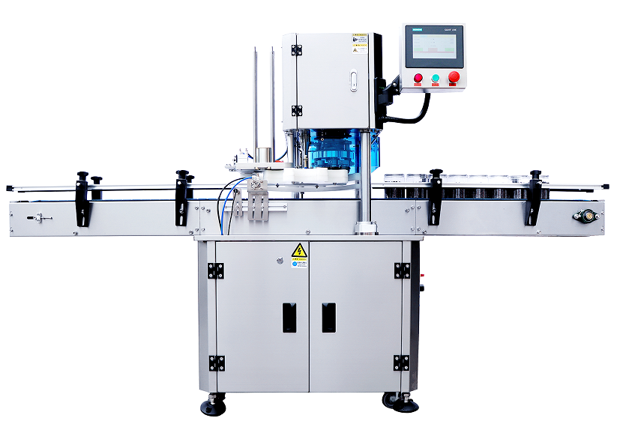
Equipment dimension drawing：
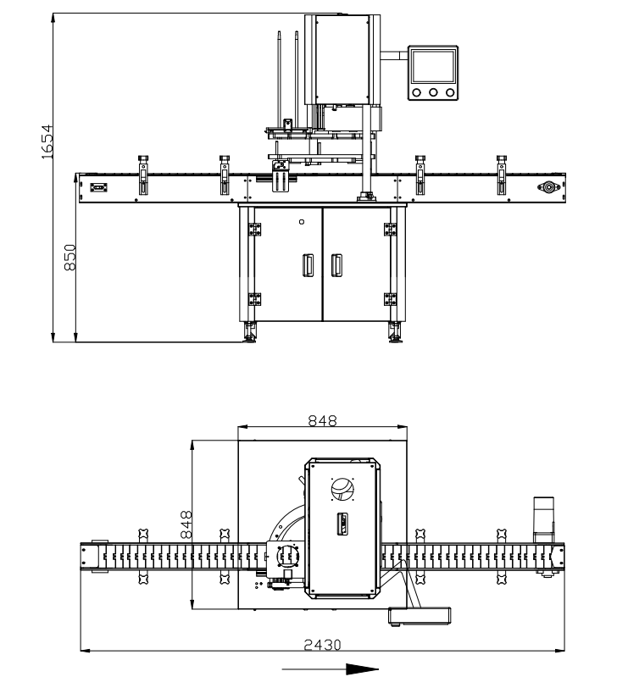

Product description
- The entire machine is servo controlled to make the equipment run safer, more stable and smarter. The turntable is started only when there is a tank; the speed of the turntable can be adjusted individually; when a deformed tank is stuck or a foreign object is stuck in the turntable, the turntable will automatically stop, effectively protecting the equipment from damage and ensuring the operator's safety. It can troubleshoot and run again, which greatly saves time and improves production efficiency.

2. A total of 4 two sealing rollers complete the sealing at the same time to ensure high sealing. Made in Taiwan and made of Japanese mold steel, the high hardness and high finish ensure the sealing is smooth, compact, no dripping, and has a long service life of up to 10 million cans.

3. The use of the internationally renowned brand Siemens PLC control system and German SICK sensor technology can ensure stable tank sealing and filling accuracy during the equipment production process, ensuring product quality and production safety.
4. It has strong versatility and can be adapted to tanks of different specifications and shapes, as well as tanks of different materials to adapt to different production needs and greatly reduce the operator's machine costs. Moreover, the can body does not rotate during the sealing process, which is safer and is also very friendly to fragile and liquid products.

5. High degree of automation, automatic lid opening and automatic sealing, which greatly improves production efficiency and reduces operating costs for business operators.
6. Low maintenance cost, the equipment's mechanical structure is simple and easy to operate, low maintenance cost, and easy to repair, which reduces production losses caused by downtime for maintenance.

Product parameters：
1.Number of sealing head: 1
2.Number of sealing rollers: 4 (2 first operation sealing rollers, 2 second operation sealing rollers)
3.Can sealing speed: 20-55 cans/minute (adjustable, related to the material, size and content of the can)
4.Can sealing height: 25-220mm (large height span requires additional molds)
5.Can sealing diameter: 30-110MM (8 stations), 60-160MM (6 stations)
6.Air consumption: 150L/min
7.Working air pressure: ≥0.6MPa
8.Working power supply: single-phase AC220V 50/60Hz
9.Total power: 1.7KW
10.Net weight: 330KG (approx.) Gross weight: 400KG (approx.)
11.Conveyor belt height: 850mm
12.Main material of equipment: 304# stainless steel
13.Equipment appearance dimensions: length 2430*width 848*height 1654mm (approx.)
14.Packing wooden box size: length 1210*width 960*height 1730MM
Configuration table (standard configuration, actual production will be partially adjusted, subject to final production)
No. | Part name | Brand | Origin | Picture
1 | PLC | SIEMENS | Germany | 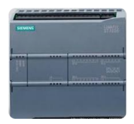
2 | Touch screen | SIEMENS | Germany | 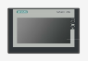
3 | Seaming Bearings | NSK | Japan | 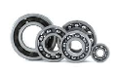
4 | Frequency converter | DELTA/SIEMENS | Taiwan/Germany | 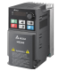
5 | Photoelectric sensor | SICK/AUTONIX | Germany/Korea | 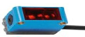
6 | Proximity detector | PANASONIC | Japan | 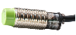
7 | Relay | SIEMENS | Germany | 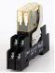
8 | Fuse base | SCHNEIDER | France | 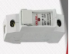
9 | Breaker | SCHNEIDER | France | 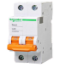
10 | Button | SCHNEIDER | France | 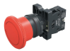
11 | Pneumatic component | SYMTECH/AIRTAC | Italy/Taiwan | 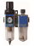  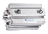  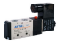
12 | Servo motor | INOVANCE | China | 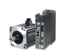
13 | Switch power | DELTA | Taiwan | 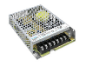
14 | Conveyor belt motor | VTV | Taiwan | 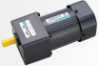
15 | Frequency converter of conveyor belt motor | KEKEN | China | 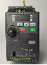
16 | Seaming motor | MODUOLI | China | 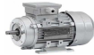
17 | Seaming roller | HSIEH | Taiwan | 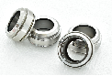
18 | Turntable | PE | LPE | 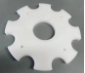

Random Toolbox Checklist:
NO. | Accessory/Tool Name | Quantity | Remark
1 | key | 2 items | Equipment door key
2 | fuse | 1 piece | accessories
3 | Hook wrench | 1 piece | tool
4 | hex key | 1 set | tool
5 | chain link | 2 sections | vulnerable parts
6 | Electric eye adjustment screwdriver | 2 of them | tool
7 | Tracheal adapter SL6-M5 | 2 of them | accessories

Suggested randomly available accessories for purchase:
NO. | Accessory name | Quantity | Unit price(USD)
1 | Sealing head | 1 pc | 50
2 | Sealing roller | 4(2pcs first operation, 2pcs second operation ) | 50
3 | Timing belt | 2 pcs | 7.5
4 | motor belt | 1pc | 3
5 | Conveyor belt chain plate | 2 meters | 10
6 | Sealing head spring | 1pc | 0.8
7 | Cap separating sheet | 4pcs | 7.5
8 | Face bearing of sealing head | 4pcs | 7.5
9 | Solenoid valve | 4pcs | 12
10 | Front stop cylinder | 1pc | 11.5
11 | Tray cylinder | 1 pc | 30
12 | Cap feeder cylinder | 1pc | 11
13 | Machine Frequency converter | 1pc | 200
14 | Conveyor frequency converter | 1pc | 75

