
GUANGDONG LEVA PACKAGING EQUIPMENT CO., LTD
Add: No. 3, Gongye South Road, Mingzhu Industrial Park, Conghua District, Guangzhou City, Guangdong Province,China. 510900
TEL：020-37510321 WEB：www.levapack.cn EMAIL：info@levapack.com

Name：Fully automatic vacuum nitrogen filling sealing machine
Model：LPE-FVC20
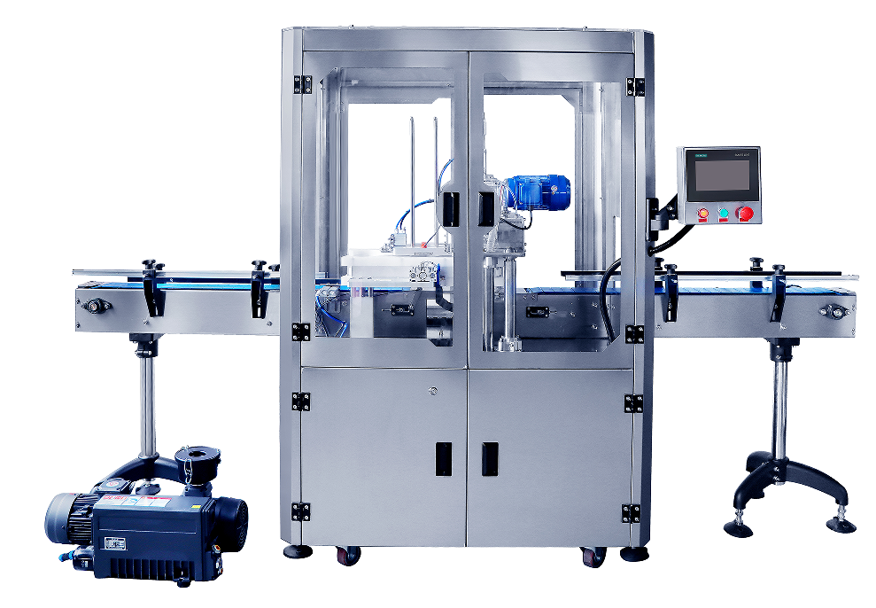

Main Feature:
1. The sealing motor adopts a servo motor, which enables controllable and adjustable sealing speed and higher sealing precision, ensuring 100% sealing integrity for the cans.
2. The residual oxygen content is less than 3%, and ultra-low residual oxygen content helps preserve freshness and prolong the shelf life of the product.
3. Four sealing rollers, in two groups, complete sealing simultaneously, ensuring high sealing integrity. Made of Japanese mold steel of Taiwan manufacturing, the rollers have high hardness and gloss to guarantee flat and compact sealing without any leakage, and can offer a long service life up to 10 million cans.
4. The internationally renowned Siemens PLC control system and SICK sensors from Germany ensure stable sealing integrity and filling accuracy during production, ensuring product quality and production safety.
5. With strong versatility, the machine can adapt to cans of different sizes, shapes and materials, meeting varied production demands and reducing the operating cost for operators. Moreover, the cans do not need to rotate during the sealing process, making it safer and more friendly to fragile or liquid products.
6. The high degree of automation lowers the operating cost of operators as the machine automatically closes and seals the lid, significantly increasing production efficiency.
7. The machine has a simple mechanical structure and is easy to operate and maintain with a low maintenance cost. It also offers easy repairs, reducing production losses caused by machine downtime for maintenance.

Main Parameters:
1. Number of sealing heads: 2
2. Number of sealing rollers: 8 (4 for the first sealing process, 4 for the second sealing process)
3. Sealing speed: 8-12cans/minute (depending on can material, size, content, and residual oxygen level standards)
4. Sealing height: 50-190MM
5. Sealing diameter: 50-127MM
6. Air consumption (compressed air): 40L/Min
7. Operating air pressure: ≥0.6MPa
8. Nitrogen gas consumption: 60L/Min
9. Residual oxygen level ≤3%
10. Power supply: Three-phase AC380V 50/60Hz
11. Total power: 5.0KW
12. Net weight: 850KG (approximately) Gross weight: 950KG (approximately)
13. Conveyor belt height: 850mm
14. Main material of equipment: 304# stainless steel
15. Equipment dimensions: Length 3000*Width 805*Height 1749mm (approximately)
16. Packaging wooden case dimensions: Length 2000*Width 1040*Height 1970MM

Configuration List(Standard configuration, some adjustments may be made in actual production, subject to final production)
No. | Part name | Brand | Origin | Picture
1 | PLC | SIEMENS | Germany | 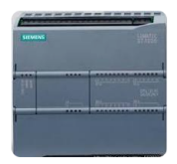
2 | Touch screen | SIEMENS | Germany | 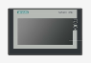
3 | Bearings | NSK | Japan | 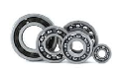
4 | Photoelectric sensor | SICK | Germany | 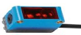
5 | Proximity detector | PANASONIC | Japan | 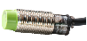
6 | Relay | SIEMENS | Germany | 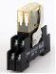
7 | Fuse base | SCHNEIDER | France | 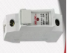
8 | Breaker | SCHNEIDER | France | 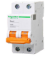
9 | Button | SCHNEIDER | France | 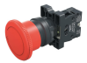
10 | Pneumatic component | SYMTECH/AIRTAC | Italy/Taiwan | 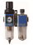  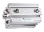  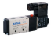
11 | Servo motor | INOVANCE | China | 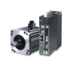
12 | Switch power | DELTA | Taiwan | 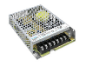
13 | Conveyor belt motor | VTV | Taiwan | 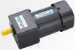
14 | Frenquency converter of conveyor belt motor | KEKEN | China | 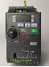
15 | Seaming roller | HSIEH | Taiwan | 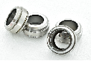
16 | Activate the three-piece ball valve | JIUMU | China | 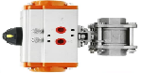
17 | Vacuum motor | WANJING | China | 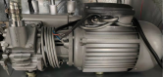
18 | Contactor | SCHNEIDER | France | 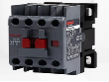
19 | Magnetic switch | AIRTAC | Taiwan | 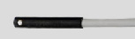
20 | Thermal overload relay | SCHNEIDER | France | 